**DS SYNOPSIS**

**1.Title -**

Hospital Management System Using RMI

**2.Project Partners -**

1.Vaibhav Gole(402062)

2.Rishikesh Kakad(402075)

3.Yoganand Kanhed(402077)

4.Vibhor Kedia(402078)

**3.Domain -**

Distributed System, Remote Method Invocation, Client-Server Communication.

**4.High Level Design -**

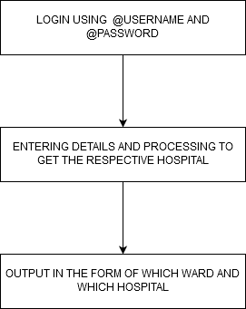

**5.System Architecture -**

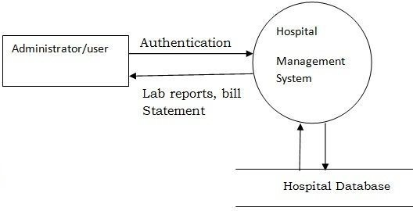

**6.Software/Hardware Requirements -**

1.Ubuntu 16.04

2.64-bit OS

3.Eclipse IDE

4.Java JDK

**7.Applications -**

1.Can be applied to connect different hotel chains.

2.Can be applied to different Governmental agencies for better public service

**8.Future Scope -**

1.Extended to form a global ecosystem for hospitals.

2.Extended to connect hospitals through blockchain technology

**9.References -**

1.Sukumar Ghosh, “Distributed Systems : An Algorithmic Approach”, Chapman and Hall/

CRC Press, Second Edition, 2015

2.https://www.tutorialspoint.com/software_architecture_design/distributed_architecture.htm

**10.Screenshots -**

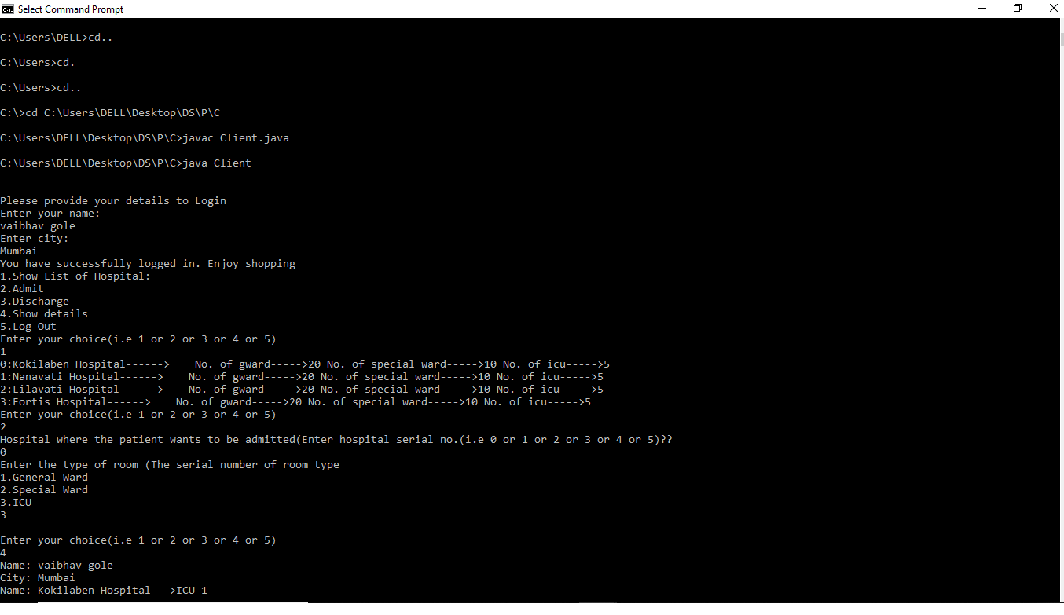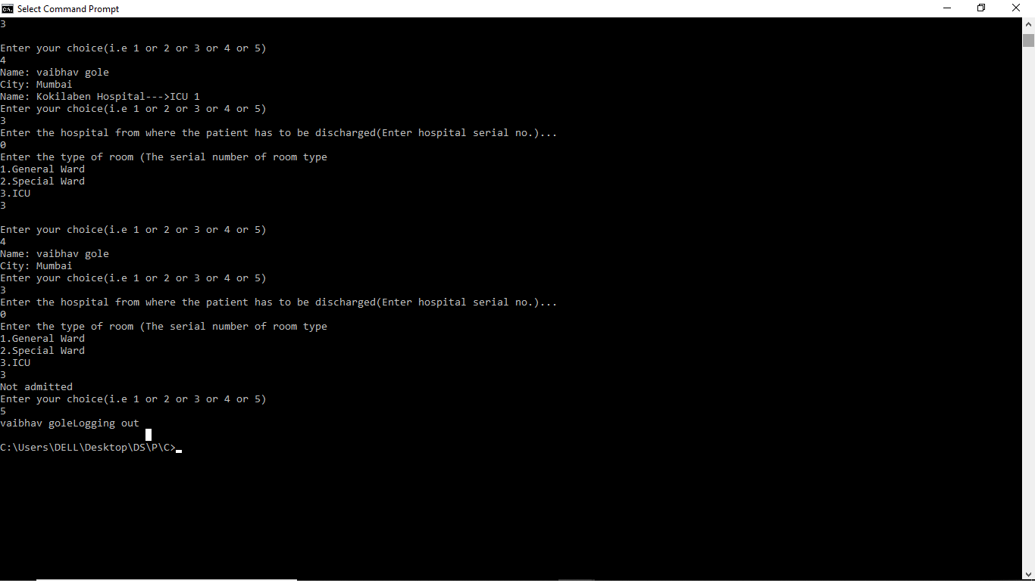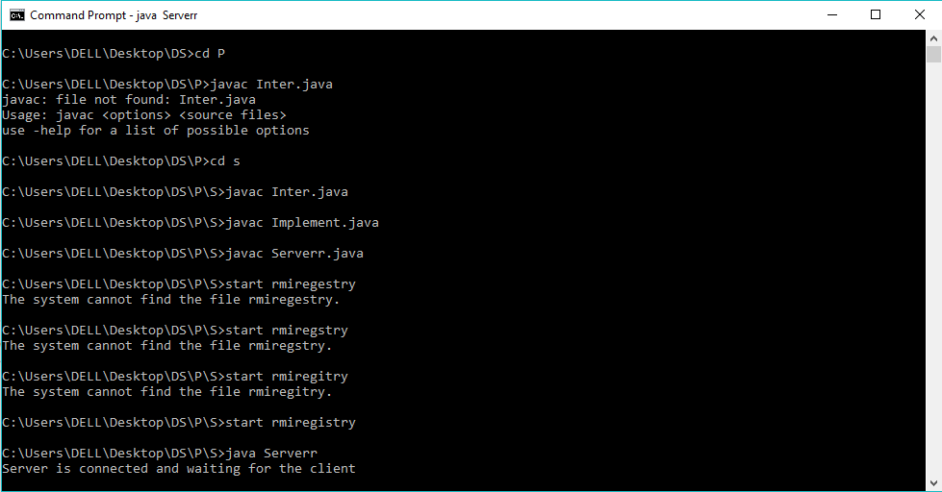

**Conclusion:**

A Distributed Database (DDB) is a collection of data which is logically interrelated and distributed over various sites of a computer network.Distributed database has some unique characteristics which make the design of consistency controlled system both challenging and interesting.We successfully implement RMI java to Develop Hospital management system.